Gelb: Harvesting Input

Grün: VDD_STS

Blau: VDD_LTS

Rot: VSUP @ 10 kOhm Last

Externer LTS:

LTS = 3300 uF

Interner STS:

STS = 100 uF

Allgemeine Konfiguration:

Measure Type = Open Voltage

V_HRV_min = 4 * 73 mV = 292 mV

Recharable Battery = Yes

LDO = 2.0 V, frc_ulp_ldo = 0;

Timer = 1 s

|  |  |  |  |  |
| --- | --- | --- | --- | --- |
| Settings | | | | |
| HRV period | 16 s |  | V_bat_max_hi | 5,5 |
| HRV_meas | 1 s |  | V_bat_max_lo | 5,2 |
| STS period | 8 ms |  | V_bat_min_hi_dis | 2,9 |
| LTS period | 16 s |  | V_bat_min_hi_con | 1,9 |
| Bat. Low V Prot. | off |  | V_bat_min_lo | 1,8 |
| Mppt | 88 % |  | V_apl_max_hi | 3,5 |
| 2 Dioden 1N4148 |  |  | V_apl_max_lo | 3,0 |

Unbrauchbar, da V_bat_max_hi zu hoch

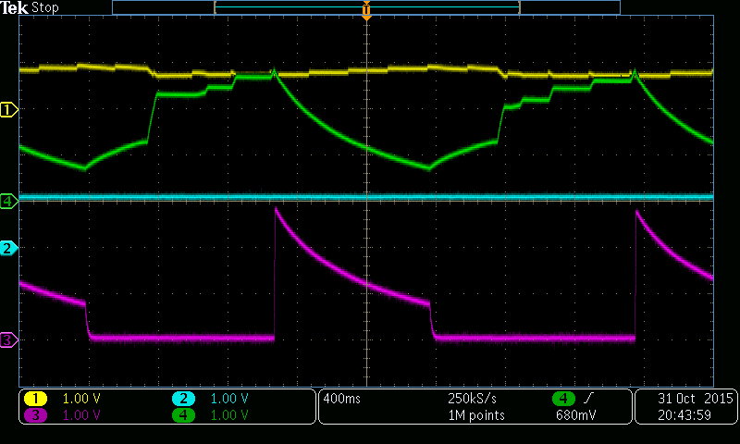

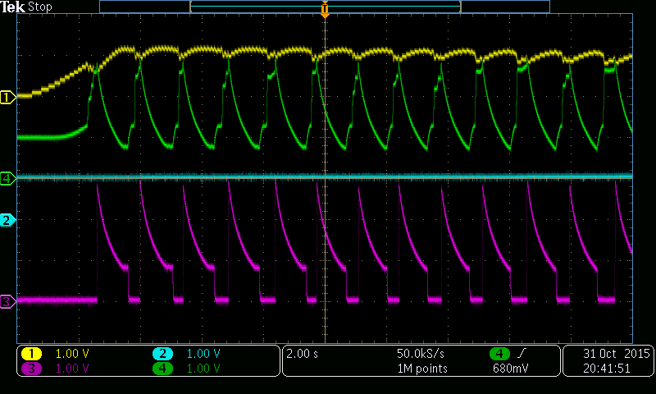

|  |  |  |  |  |
| --- | --- | --- | --- | --- |
| Settings | | | | |
| HRV period | 16 s |  | V_bat_max_hi | 4,2 |
| HRV_meas | 1 s |  | V_bat_max_lo | 4,1 |
| STS period | 16 ms |  | V_bat_min_hi_dis | 2,9 |
| LTS period | 16 s |  | V_bat_min_hi_con | 1,9 |
| Bat. Low V Prot. | on |  | V_bat_min_lo | 1,8 |
| Mppt | 88 % |  | V_apl_max_hi | 3,5 |
| 3 Dioden 1N4148 |  |  | V_apl_max_lo | 3,4 |

LTS gibt keine Energie zurück

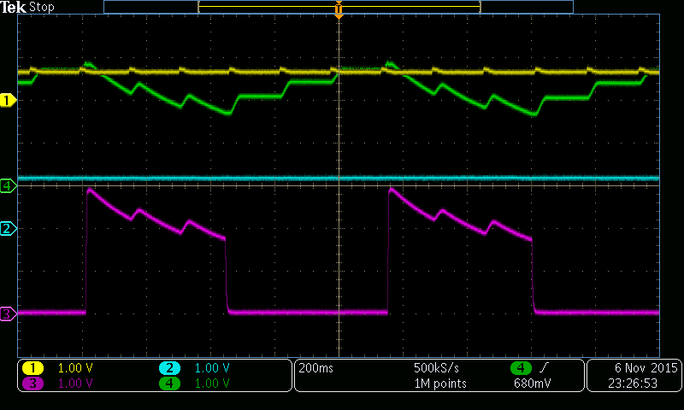

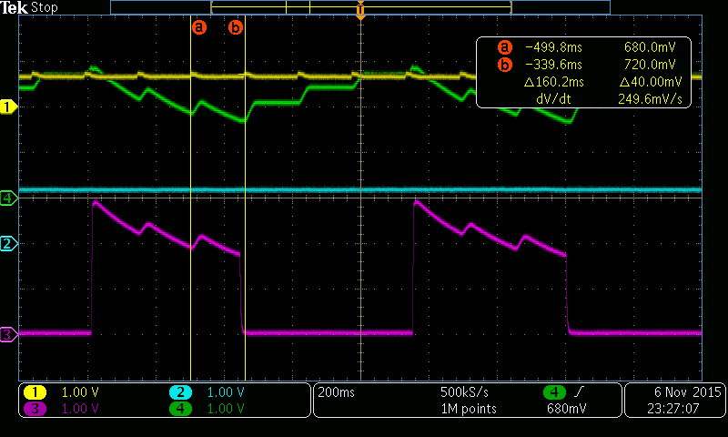

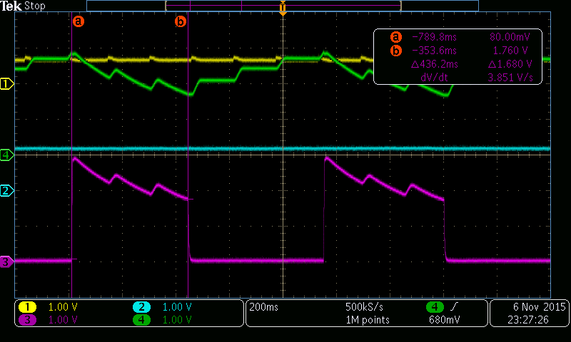

|  |  |  |  |  |
| --- | --- | --- | --- | --- |
| Settings | | | | |
| HRV period | 16 s |  | V_bat_max_hi | 4,2 |
| HRV_meas | 1 s |  | V_bat_max_lo | 4,1 |
| STS period | 16 ms |  | V_bat_min_hi_dis | 3,3 |
| LTS period | 16 s |  | V_bat_min_hi_con | 1,9 |
| Bat. Low V Prot. | on |  | V_bat_min_lo | 1,8 |
| Mppt | 88 % |  | V_apl_max_hi | 3,5 |
| 3 Dioden 1N4148 |  |  | V_apl_max_lo | 3,4 |

LTS gibt keine Energie zurück

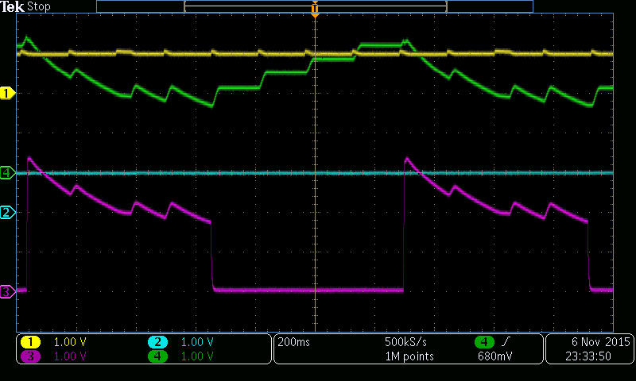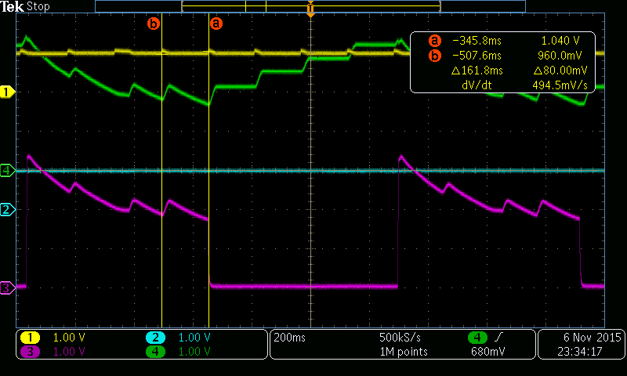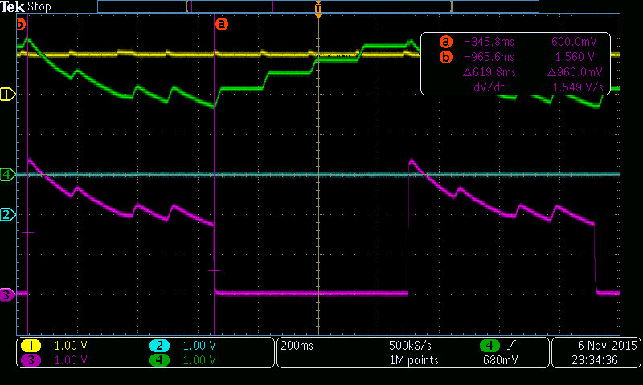

|  |  |  |  |  |
| --- | --- | --- | --- | --- |
| Settings | | | | |
| HRV period | 8 s |  | V_bat_max_hi | 4,2 |
| HRV_meas | 1 s |  | V_bat_max_lo | 4,1 |
| STS period | 16 ms |  | V_bat_min_hi_dis | 2.9 |
| LTS period | 16 s |  | V_bat_min_hi_con | 2,1 |
| Bat. Low V Prot. | on |  | V_bat_min_lo | 1.8 |
| Mppt | 88 % |  | V_apl_max_hi | 3,5 |
| 3 Dioden 1N4148 |  |  | V_apl_max_lo | 3,4 |